ACRYLIC PAINTING with Lynne Drake
Friday June 10th: MASTER SERIES “HENRI MATISSE”

DESCRIPTION:

Students will create a painting in the style of French Fauvist painter Henri Matisse

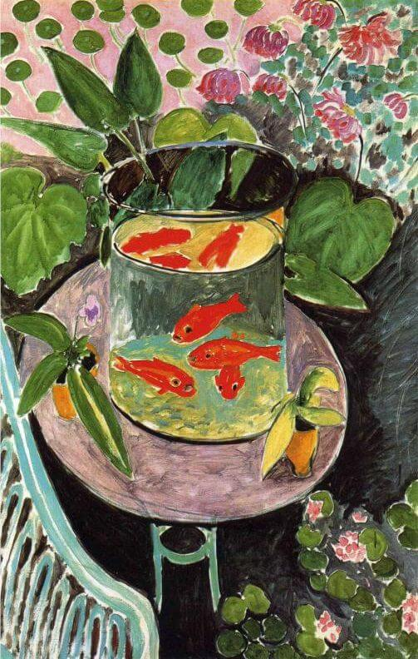
OBJECTIVE:
- Enjoy creating art in a shared environment
- Paint a canvas in the style of Henri Matisse
- Understand basic properties of acrylics, composition,
color & principles
- Develop painting skills, styles and techniques
- Practice eye-hand coordination through observation
TIME: 1 - 4pm (take a break as desired)

COST: $25

PAYMENT INFO: Register in the “Class Binder” located in the art room
Place CAM slip or check in the attached envelope in binder

MATERIALS:
(Supplies are not included.)

- Will need at least primary paint colors plus black and white.
- Prefer a 16 x 20 canvas, palette, brushes, paper towels and a water cup.
- Supplies can be purchased locally at Michaels, Hobby Lobby or online.
- Basic supplies are provided for an additional $10 – includes a 16 x 20 canvas.
- (Please let me know by June 7th if you need supplies)

LEVEL: All levels (highly recommend beginners take the 4-week foundation course)
LIMIT: Min 5 / Max 12

SIGN UP BY: June 7th

SPECIAL INSTRUCTIONS: Can either copy or paint in style of Matisse using your own photo

Sample photos of various Matisse paintings are provided for reference or you can download a preferred photo to your phone or pad. It’s easier to zoom in for details.
* Also try to bring paint colors that reflect the color palette that you will be using.

Click below or paste in your browser to download photos:
https://www.henrimatisse.org/
CONTACT INFO: Email: ldrake.scartclub@gmail.com / Text: 631-766-3752
Expect an email with details about a week before class
(Please contact me with any questions)

